Chad Carmickle 1/24/19

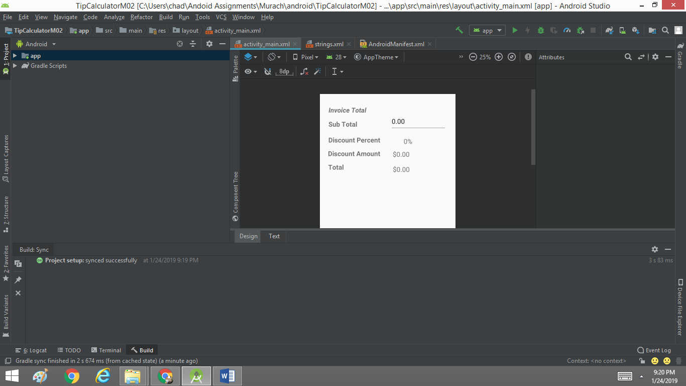

ID Names

Some of the ID names I made used lbl, short for label and input for the edit text file.

Lbl_invoice_Total , Lbl_Sub_Total , Lbl_Discount_Percent , Lbl_Discount_Price , Lbl_Total

These five ID names are the ones I used for my labels on the left portion of the app.

Input_Bill_Amount , Lbl_Percent_Amount, Lbl_Discount_Amount , Lbl_Total_Amount

For the four labels and text I used the ID’s above I made sure to add the keyword **Amount** to refer to those as the final numbers to appear for the user.

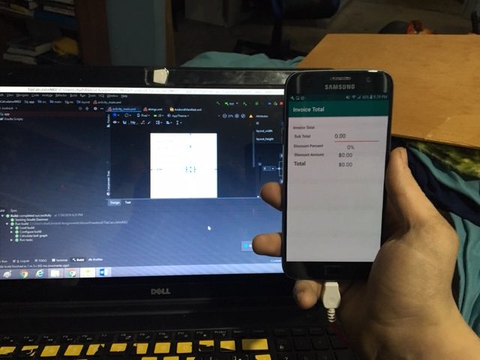

I lastly uploaded the program to my phone to test out any bugs and features.